Agenda Item 5 – Conical Sphere
THE LIGHT
... is a 4metre in diameter globe that is lit from both the inside and projected onto the outside.
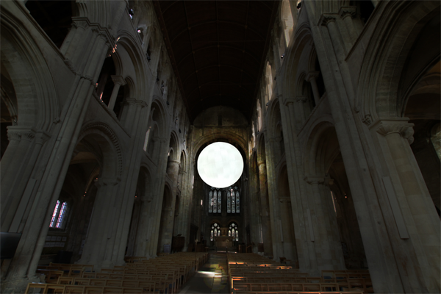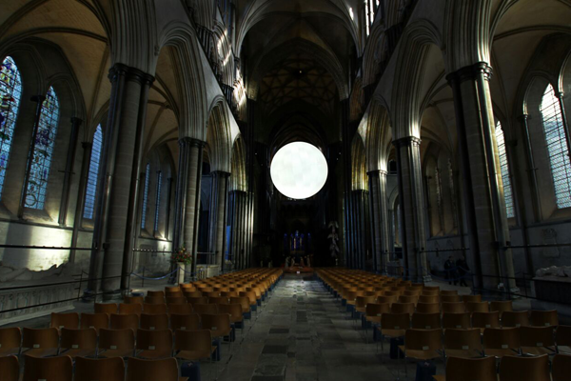
[Above] Artist Impressions. The Light will be installed in Romsey Abbey and Salisbury Cathedral, starting with Romsey in February 2017.
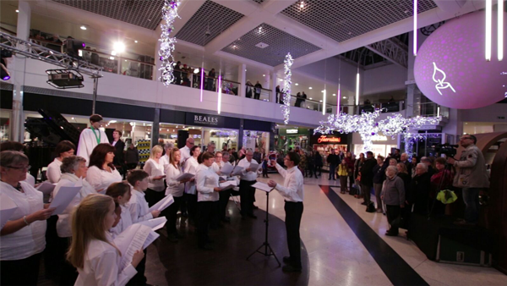
[Above] The Light launched in November 2015 in Poole Dolphin Shopping Centre.
The launch ceremony involved a community choir put together specially for the performance, and featured projected interviews of local people talking about what Light meant to them.

Watch The Film...
To see footage from the 2015 project and to hear artist Richard McLester explain more about the art installation, watch the short film below...
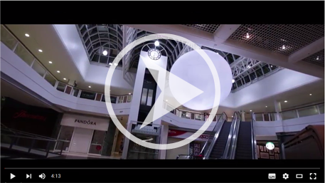
https://www.youtube.com/watch?v=J6dLgvp5zus
Looking Forwards...
The theme for Romsey 2017 will be about highlighting Mental Health, and we are looking to expand the launch ceremony to include a wide-ranging collection of arts, including dance, performance art and new media.
The launch ceremony will take place on 4th February 2017 and the installation will hang in Romsey Abbey for 5 weeks.
How Can You Help?
Business Support
We are looking for businesses to partner with us who can benefit from the visibility that will be generated from the project & help develop the local community.
The project is made up of a small number of professionals whose goal is to enable a large number of volunteers to come together and create the project as a whole. As a community interest company, our work is entirely not for profit.
We have a variety of creative ways in which your business can support your local community through The Light.
Creative Opportunities
We are also looking for local creatives who can benefit from being involved, from choirs/singers to visual artists & performers, back-stage and film/photography crew. We are used to working with a people of all backgrounds, ages and abilties.
If you can help, please do get in touch.
Email: richardmclester@music.conicalsphere.com
Phone: 01202 984 784
Website: http://music.conicalsphere.com

Kind Regards,
Richard McLester


