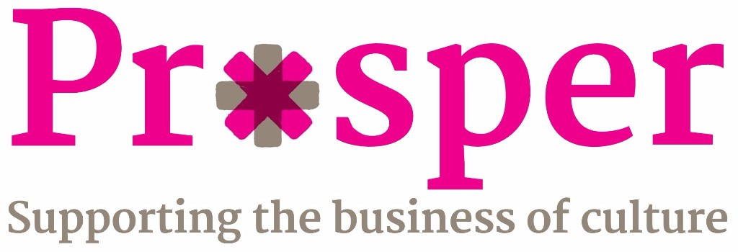

Creative United are thrilled to announce our new Arts Council England-funded business support programme, Prosper, opening for applications 27th March 2017.
Prosper will offer arts and cultural organisations, museums, libraries, creative companies and individual entrepreneurs the opportunity to participate in nine months of free, dynamic and impactful business support activities. Read the full press release on our website.
Join us at one of our Prosper briefing events across England where you can find out more about the programme, who it's for and how to get involved. It's also an opportunity to hear from our programme partners and ask any questions you may have.
Attendance is free and we welcome anyone who's interested in finding out more, so please do share this invitation with your networks, colleagues and friends and help spread the word.
RSVP via the links below. We look forward to welcoming you!
London, The Foundling Museum
Monday 27th March - 9:45am-11:00am RSVP here
Hull, Northern Academy of Performing Arts
Wednesday 29th March - 8:45am - 10:00am RSVP here
Norwich, Writers' Centre
Friday 31st March - 9:45am-11:00am RSVP here
Coventry, TechnoCentre
Monday 3rd April - 9:45am-11:00am RSVP here
Liverpool, Play Space
Thursday 6th April - 9:45am-11:00am RSVP here
Southampton, City Art Gallery
Tuesday 11th April - 9:45am-11:00am RSVP here
Newcastle, Arts Centre
Thursday 13th April - 9:45am-11:00am RSVP here
To find out more about Prosper and how to apply, please visit our website: http://www.creativeunited.org.uk/programme/prosper/
If you'd like to get in touch, please email: sarah.thirtle@creativeunited.org.uk

Prosper partners

