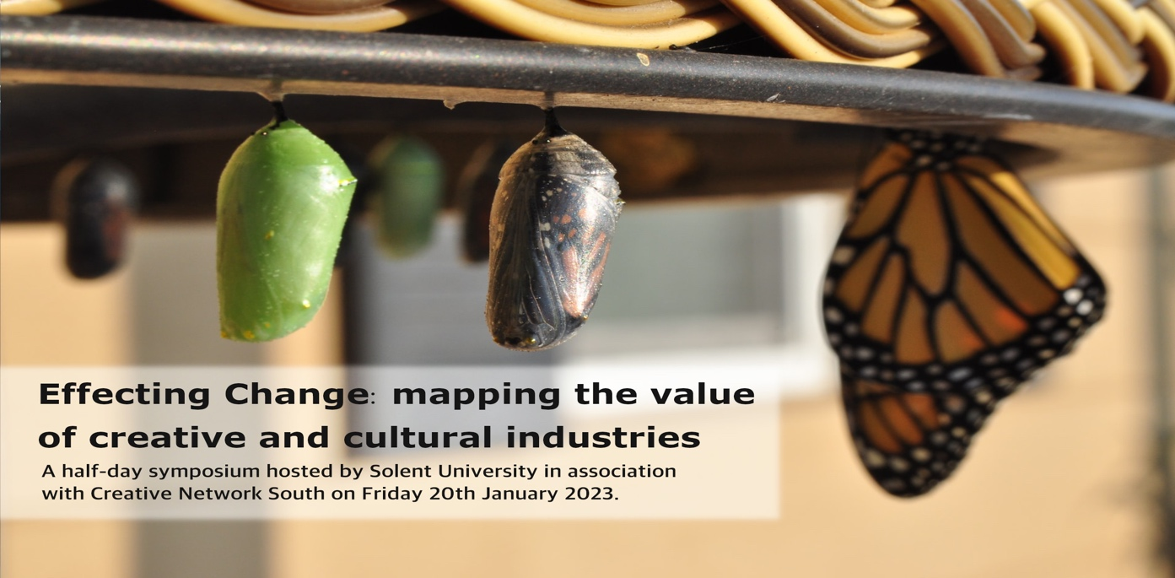

Effecting Change: mapping the value of creative and cultural industries

A half-day symposium hosted by Solent University in association with Creative Network South on Friday 20th January 2023.

The symposium features presentations by scholars working in the field of creative and cultural industries who have insights to share with peers, industry stakeholders and with those who share a passion for growth and development of the creative and cultural sector. Our aim is to foster collaboration and partnership between scholars, industry, and policymakers, in order to provide evidence in support of the ongoing strategic development of the creative and cultural sector at a regional, national, and/or international level.

After a light working lunch, the afternoon opens with a presentation from Research Fellows Hanna Klien-Thomas and Maya Nedyalkova who will reflect on the achievements of Creative Industries Research and Innovation Network at Oxford Brookes University. Followed by Dr Simon Eden who has been very busy working on giving voice to the Solent regions creative and culture sector. Expect an update on what’s next for the Solent as well as an informative discussion on the value of voice. Then we have Dr. Josh Siepel who works closely with the AHRC Creative Industries Policy and Evidence Centre (PEC) brining us news of his latest research. The symposium includes further presentations on as diverse a range of subjects as; creative ecologies, ecosystems and talent pipelines, business innovation and sustainability in fashion.

Whether you are a researcher, a policy maker, industry professional of a creative the symposium aims to start a conversation in the Solent region that will put the creative and cultural sector at the heart of our strategy for growth.
For full details of the programme and to book a (free) place follow the link to the website.

Photo by Suzanne D. Williams on Unsplash

Time: 12-4pm

Date: Friday 20th January 2023

Location: TS315A/B, The Spark, Solent University, East Park Terrace, Southampton SO14 0YN

Webpage
https://creativemediapractice.com/index.php/2022/11/12/effecting-change/

Eventbrite
https://www.eventbrite.com/e/effecting-change-mapping-the-value-of-creative-and-cultural-industries-tickets-462166250697

Contact
Dr Roy Hanney
Roy.hanney@solent.ac.uk
07894 899 044

